Practical 5
Definition : Generate bar, line, and scatter plots to visualize monthly revenue and add labels, titles, and legends.
Outcomes / Learning : This experiment demonstrates how to use Python's Pandas and Matplotlib libraries to import data, clean it, and visualize it using various plots.
Working : The experiment involves importing a CSV file, creating a DataFrame, and then generating different types of plots—bar, line, and scatter—to analyze the data.

Step 1 : This is the initial step of the process, showing the import of the dataset and its preview to understand the data structure.
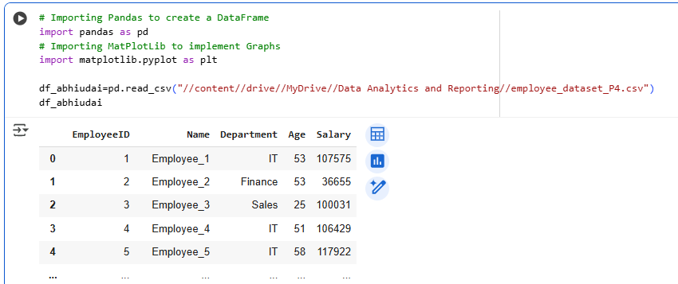

Step 2 : Line Graph : The line graph in this image visualizes the distribution of Salary data across various Departments.
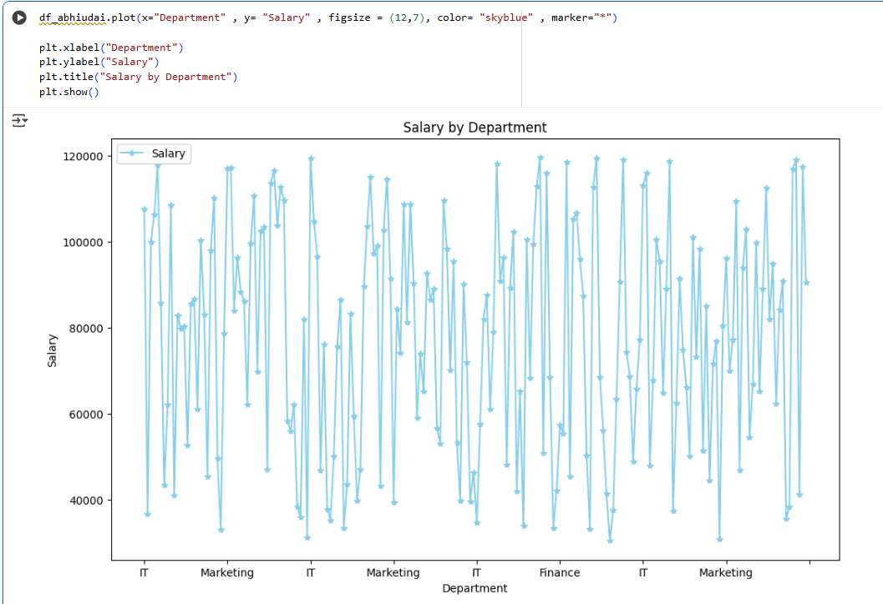

Step 3 : Bar Graph: This bar graph provides a clear comparison of the average salary across different departments. (Taking Sample Dataset of Days and Revenue By Importing pandas and matplot libraries)
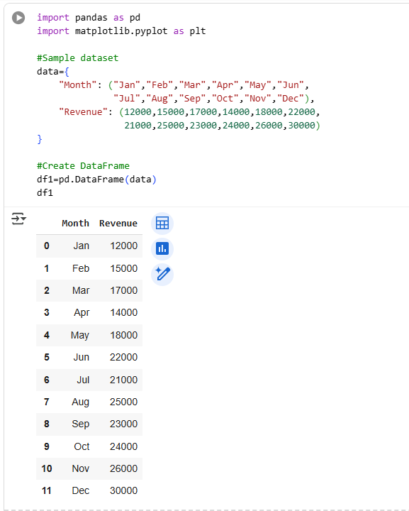
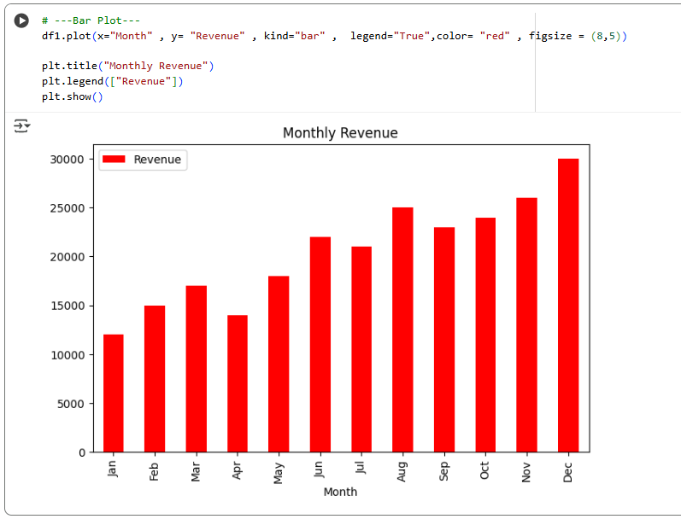

Step 4 : Scatter Plot: This image shows a scatter plot that is used to analyze the relationship between two numerical variables: Age and Salary.
